Ekovya
CREATION PRODUCT SHEET (general, bundle, up sells and cross sells) / ACCOUNT CREATION / SEARCH PRODUCT / ORDER ON WOOCOMMERCE VIA WORDPRESS

How create product sheet ?
On the dashboard of Sandboxe Wordpress, go to menu on the left and click on product.
1
1

2
On the page Products, click on Add New located at the top

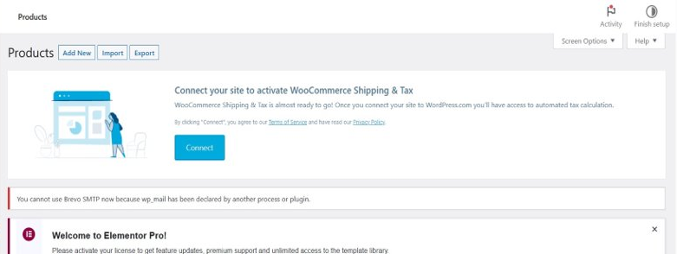

3
Add product name

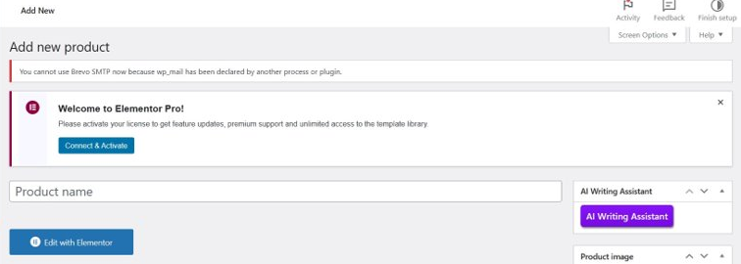

4
Add product description

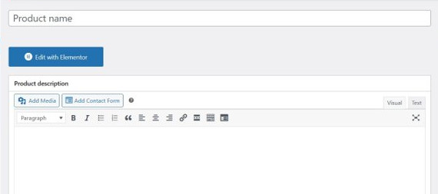

Add general informations (price, promo, VAT…)
5

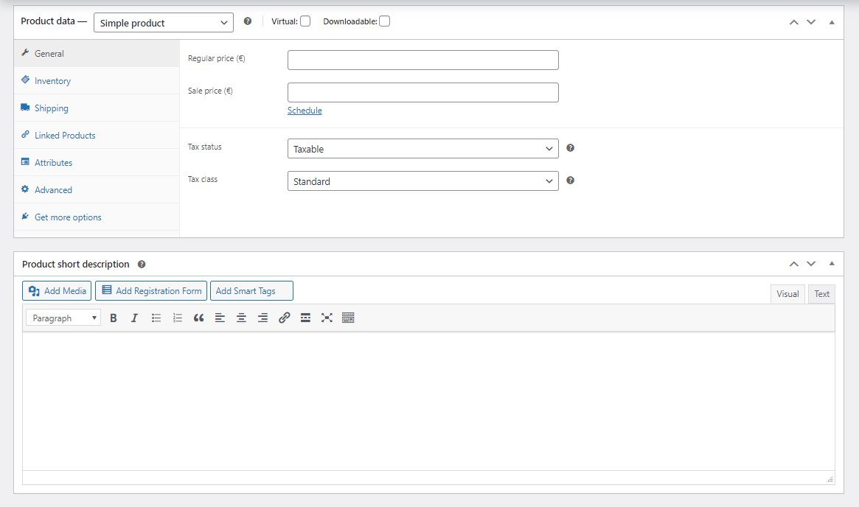

Add inventory informations
6

Go to Product image on the right and add image
7

Add products category or create on the right
8

Add products tags on the right
9

10
1 Click on publish on the right

How create bundle ?

1
Go to Product Data and click on Smart bundle

2
Add products

How create up sells or cross sells?

1
Go to product data and linked products.

2
Add products for up sells or cross sells

How create account / validation procedure?

Go to users and choose one user for approved.
1

How search products and addition to basket

You’re a big guy/girl, you surely can find out by yourself.

Ordering a product on Ekovya

Go on Oders and click on Add order
1

Edit the order and click on create
2

